Testing document for MS Decom activities.

Program: ZPMDBR_WPFIS_MASS_QIR_UPDATE

System: xEM

CD : CD152048- MS Decom xEM

Transport Request: DEMK931402

=======================================================

Testing Program changes - ZPMDBR_WPFIS_MASS_QIR_UPDATE

1. Option to provide Google sheet URL in program selection screen.

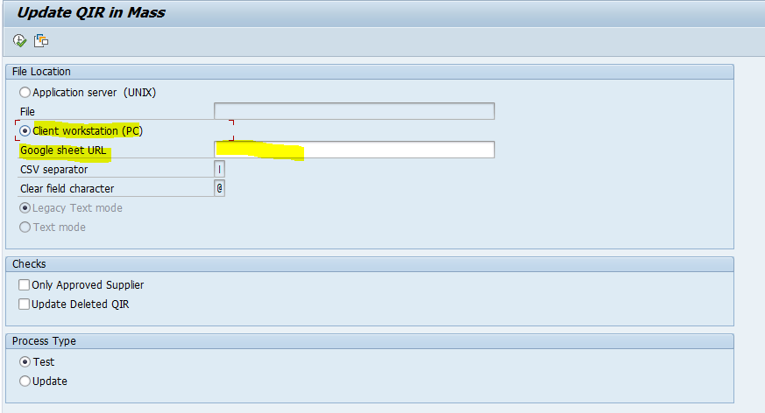

1. Template url need to be provided from google drive or select the relevant variant.

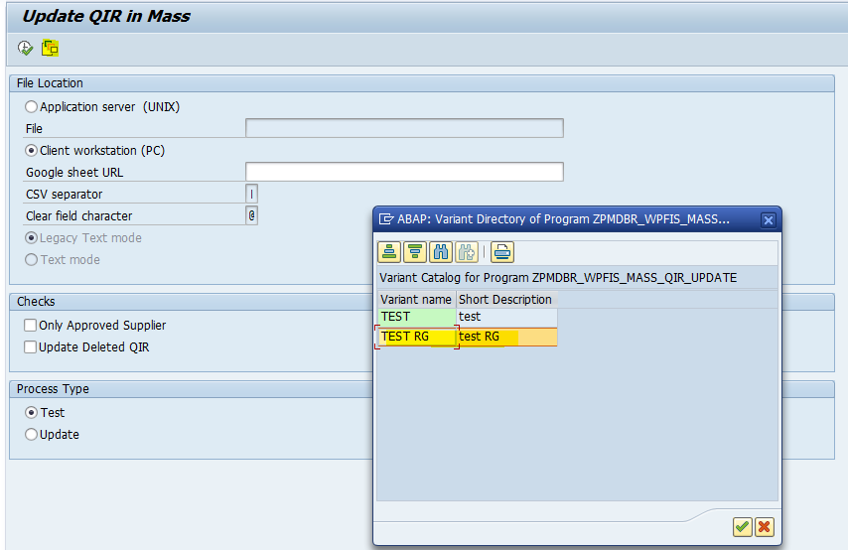

1. Execute the program after providing all details in selection screen. 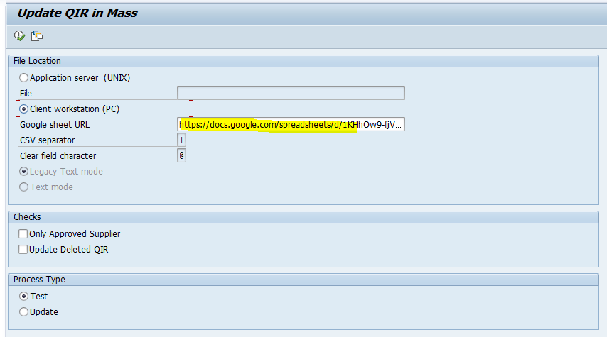

<https://docs.google.com/spreadsheets/d/1KHhOw9-fjVgKTRA3JVOHrnNX30Wc4wbwpspr4q73qvI/edit?gid=0#gid=0>

Output: Tested with 100+ sample items.